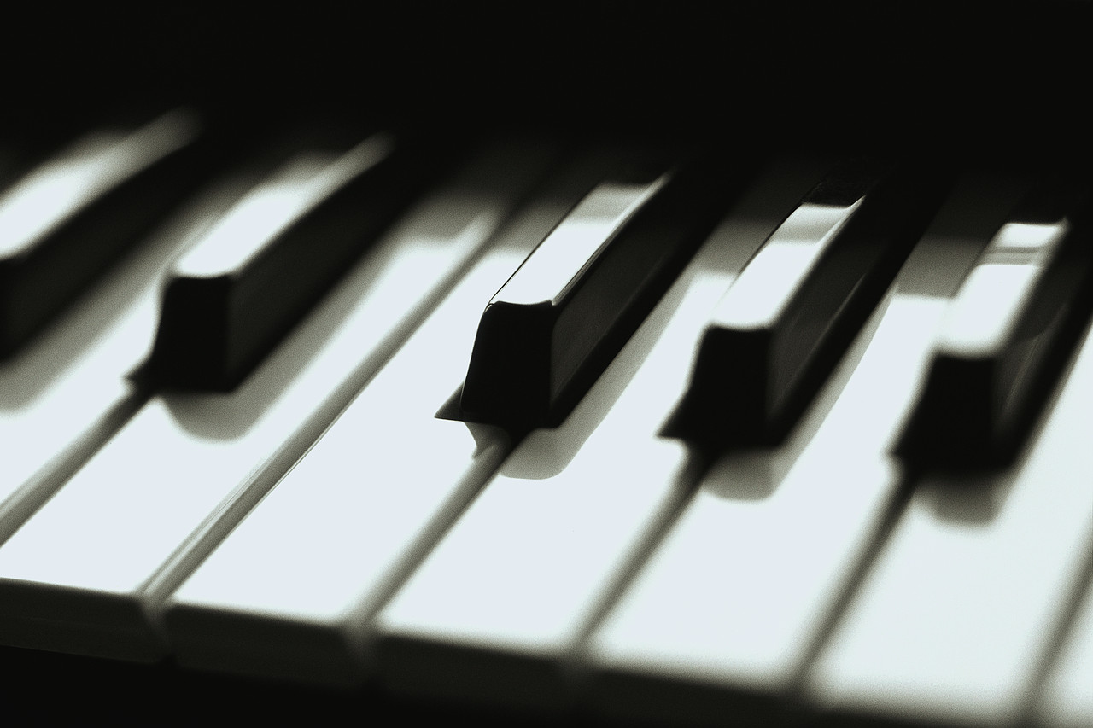Music Lessons

Piano & Flute

Charlene Sutcliffe

BA Music, Math Minor, B Education

604-746-4142

2435 Center Street

music.sutcliffe.ca